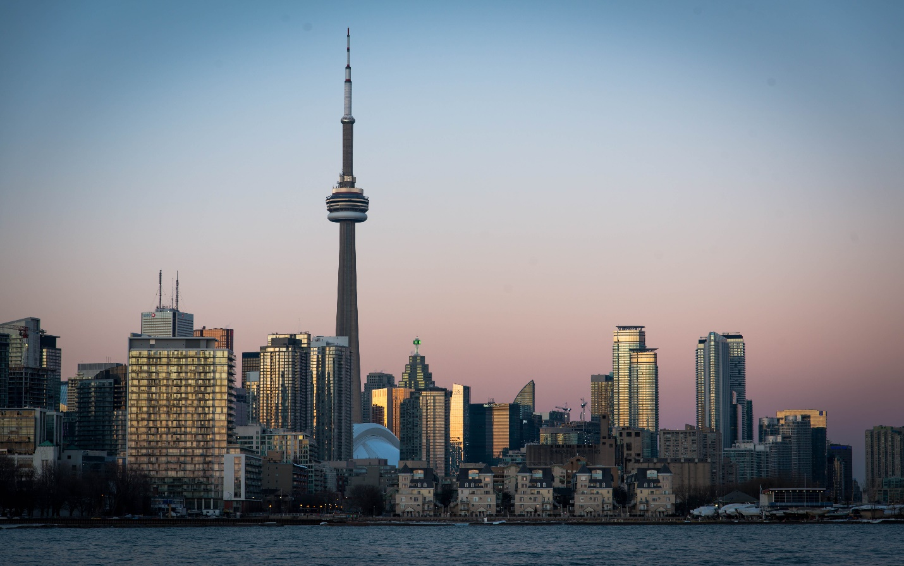

**CN Tower**

The CN Tower, located in Toronto, Canada, held the title of the world's tallest free-standing structure and tower for over three decades after its completion in 1976.

**History**

The CN Tower in Toronto, completed in 1976, was the world's tallest freestanding structure until 2009 and remains an iconic symbol of Canada.